Launch Linux EC2 instances in two regions using a single Terraform file.

**FIRST DOWNLOAD TERRAFORM AND CONFIGURE AWS**

**NOW WRITE THE MAIN.TF FILE TO CREATE TWO EC2 INSTANCE IN TWO DIFFERENT REGIONS**

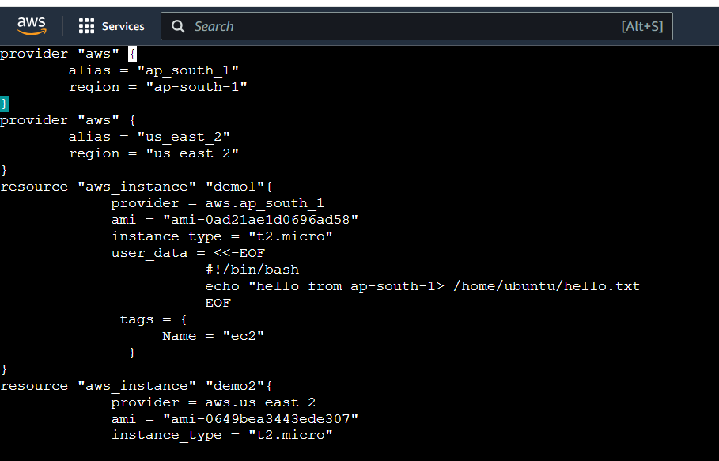

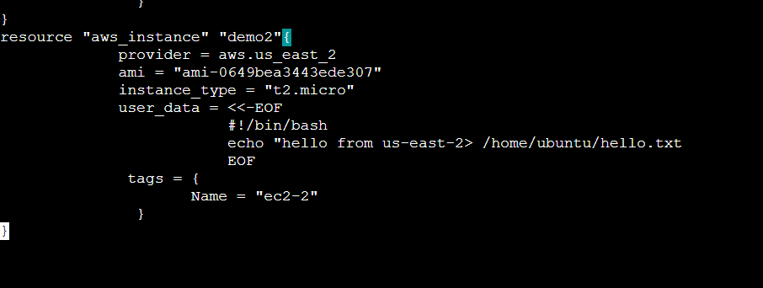

**NOW AFTER WRITING THIS FILE , EXECUTE THE FILES WITH FOLLOWING COMMANDS**

**\*TERRAFORM INIT**

**\*TERRAFORM VALIDATE**

**\*TERRAFORM PLAN**

**\*TERRAFORM APPLY**

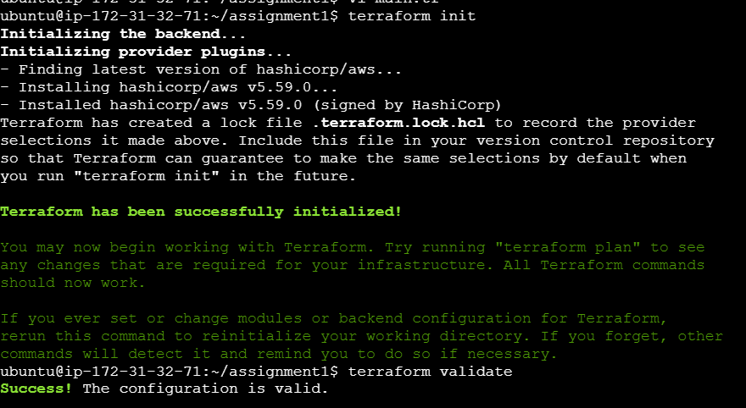

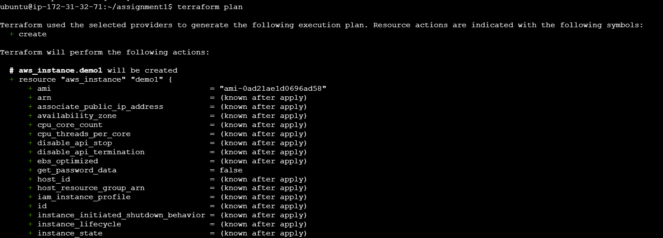

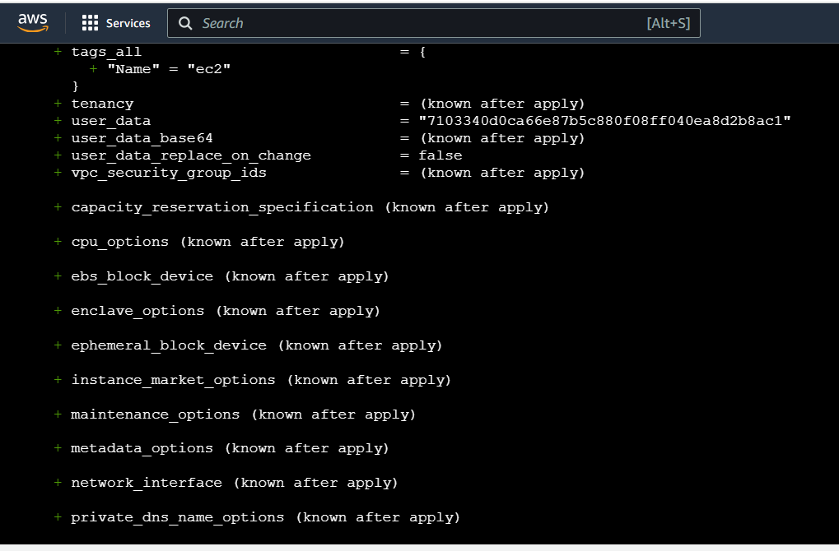

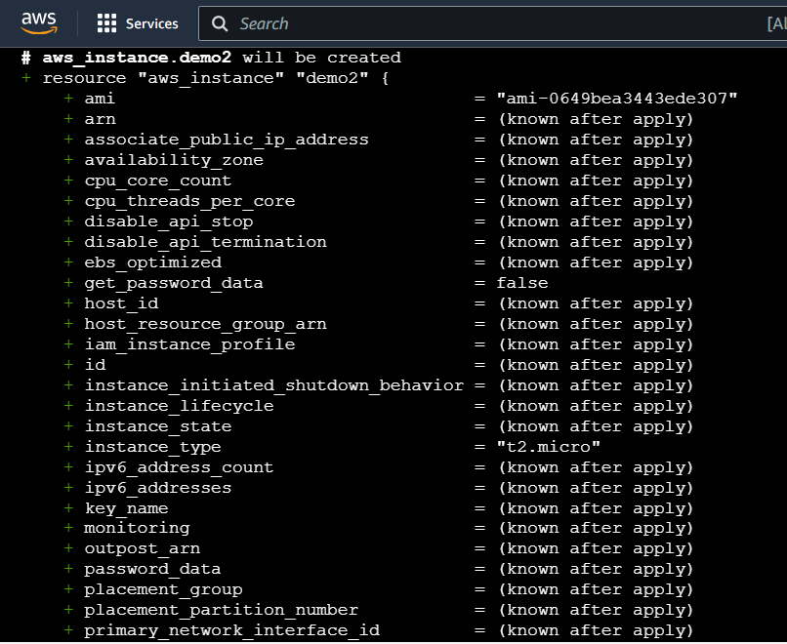

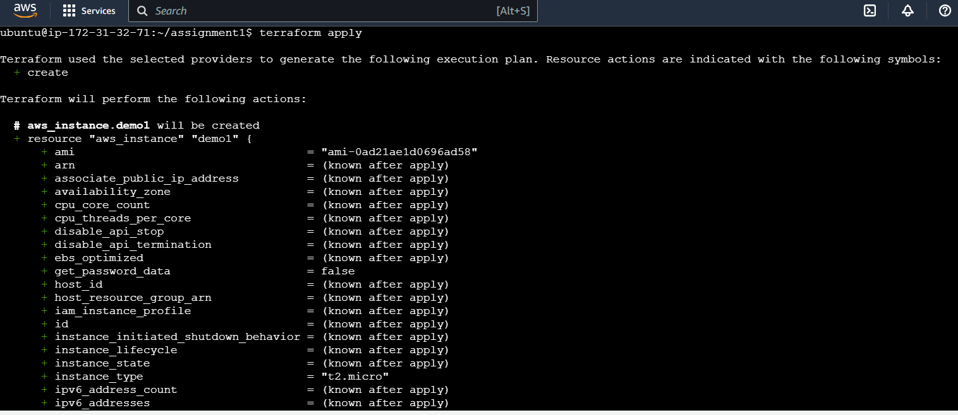

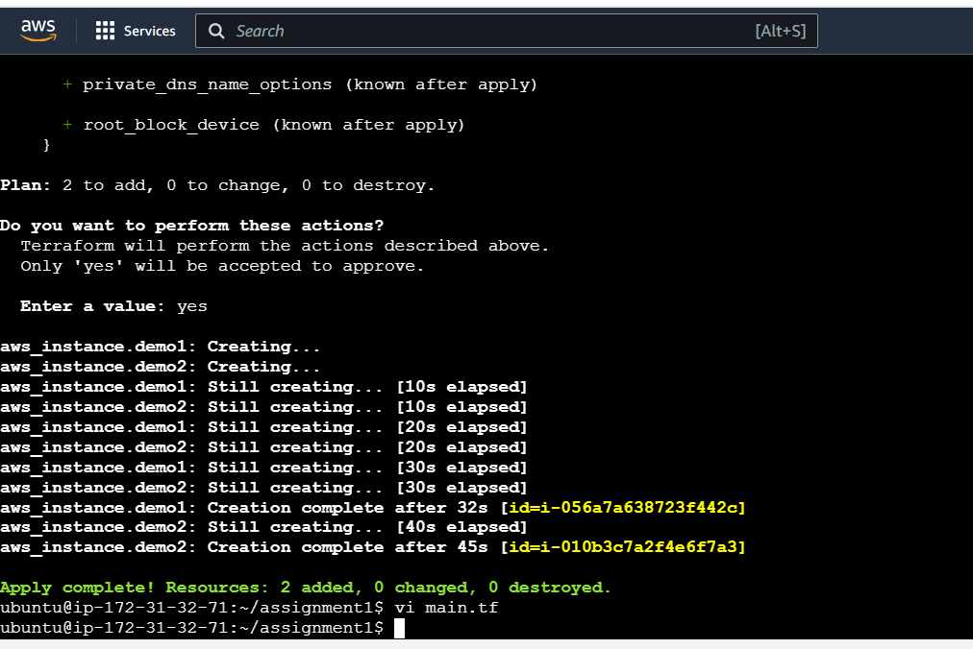

**NOW 2 EC2 INSTANCE IN 2 DIFFERENT REGION HAS BEEN CREATED**

